**Assignment #3. Advanced CSS ( Flexbox & Grid)**

**Part 1. Flexbox**

**Task 0. Navigation Bar**

1. Create a header section with a logo on the left and a list of links on the right.
2. Turn the header container into a flex container.
3. Align the logo and the links horizontally.
4. Apply spacing between the links using Flexbox properties.
5. Make sure the logo and links are vertically centered.
6. <header class="header">
7. <div class ="head-box">
8. <div class="logo">
9. <a href="../index.html">Home</a>
10. </div>
11. <nav class="head-link">
12. <ul>
13. <li><a href="#">Part 1</a></li>
14. <li><a href="#">Part 2</a></li>
15. <li><a href="#">Part 3</a></li>
16. </ul>
17. </nav>
18. </div>
19. </header>

🡨-----------------CSS----------------🡪

1. header{
2. background-color: hsl(0, 0%, 47%);
3. }
4. .head-box{
5. display: flex;
6. justify-content: space-between;
7. align-items: center;
8. width: 100%;
9. }
10. .logo{
11. margin-left:20px;
12. }
13. .head-link ul{
14. display:flex;
15. margin-right: 20px;
16. justify-content: flex-end;
17. list-style: none;
19. }
20. .head-link li{
22. padding: 5px;
23. }
24. .head-box a{
25. text-decoration: none;
26. color: aliceblue;
27. font-weight: 600;
28. font-family:'Gill Sans', 'Gill Sans MT', Calibri, 'Trebuchet MS', sans-serif
29. }



**Task 1. Card Row**

1. Create a container with at least three cards (each card should include an image, title, text, and button).
2. Make the container a flex container so the cards appear in a row.
3. Ensure all cards have equal height.
4. Add consistent gaps between the cards.
5. Add a simple hover effect (e.g., shadow, lift, or scale).
6. <!-- ---------------------cards--------------- -->
7. <h2>Part 1 cards</h2>
8. <div class="card-box">
9. <div class="cards">
10. <div class="card-img"><img src="1.jpg" alt="one"></div>
11. <div class="card-txt">
12. <h3>Project One</h3>
13. <p>
14. Lorem ipsum dolor sit, amet consectetur adipisicing elit.
15. Necessitatibus perferendis placeat error autem,
16. officia quasi consequuntur nisi minus, non commodi cupiditate repellat,
17. facere sequi mollitia rem voluptates exercitationem temporibus voluptatem.
18. </p>
19. </div>
20. <div class="card-btn">
21. <button>view details</button>
22. </div>
23. </div>
24. <div class="cards">
25. <div class="card-img"><img src="1.jpg" alt="two"></div>
26. <div class="card-txt">
27. <h3>Project Trhee</h3>
28. <p>
29. Lorem ipsum dolor sit, amet consectetur adipisicing elit.
30. Necessitatibus perferendis placeat error autem,
31. officia quasi consequuntur nisi minus, non commodi cupiditate repellat,
32. facere sequi mollitia rem voluptates exercitationem temporibus voluptatem.
33. </p>
34. </div>
35. <div class="card-btn">
36. <button>view details</button>
37. </div>
38. </div>
39. <div class="cards">
40. <div class="card-img"><img src="1.jpg" alt="three"></div>
41. <div class="card-txt">
42. <h3>Project Two</h3>
43. <p>
44. Lorem ipsum dolor sit, amet consectetur adipisicing elit.
45. Necessitatibus perferendis placeat error autem,
46. officia quasi consequuntur nisi minus, non commodi cupiditate repellat,
47. facere sequi mollitia rem voluptates exercitationem temporibus voluptatem.
48. </p>
49. </div>
50. <div class="card-btn">
51. <button>view details</button>
52. </div>
53. </div>
54. </div>

/* ------------------------card-box---------------- */

1. .card-box {
2. display: flex;
3. flex-wrap: wrap;
4. gap: 20px;
5. margin: 0 10px;
6. justify-content: space-evenly;
7. }
8. .cards {
9. flex: 1 1 calc(33% - 20px);
10. display: flex;
11. flex-direction: column;
12. background: whitesmoke;
13. border: 2px solid rgb(129, 129, 129);
14. border-radius: 10px;
15. overflow: hidden;
16. box-shadow: 0 4px 8px rgba(0,0,0,0.1);
17. transition: transform 0.3s;
18. }
19. .cards:hover {
20. transform: translateY(-5px);
21. }
22. .card-img {
23. width: 100%;
24. height: 180px;
25. background: #ccc;
26. display: flex;
27. justify-content: center;
28. align-items: center;
29. overflow: hidden;
30. }
31. .card-img img {
32. width: 100%;
33. height: 100%;
34. object-fit: cover;
35. }
36. .card-txt {
37. flex: 1;
38. padding: 15px;
39. display: flex;
40. flex-direction: column;
41. font-family: 'Gill Sans', 'Gill Sans MT', Calibri, 'Trebuchet MS', sans-serif;
42. }
43. .card-txt h3 {
44. margin: 0 0 10px;
45. }
46. .card-txt p {
47. flex-grow: 1;
48. margin: 0;
49. overflow-wrap: break-word;
50. }
51. .card-btn {
52. padding: 15px;
53. }
54. .card-btn button {
55. width: 100%;
56. padding: 10px;
57. border: none;
58. border-radius: 6px;
59. background: #444;
60. color: #fff;
61. cursor: pointer;
62. transition: background 0.3s;
63. }
64. .card-btn button:hover {
65. background: #222;
66. }
67. /* адаптив */
68. @media (max-width: 900px) {
69. .cards {
70. flex: 1 1 calc(50% - 20px);
71. }
72. }
73. @media (max-width: 600px) {
74. .cards {
75. flex: 1 1 100%;
76. }
77. }

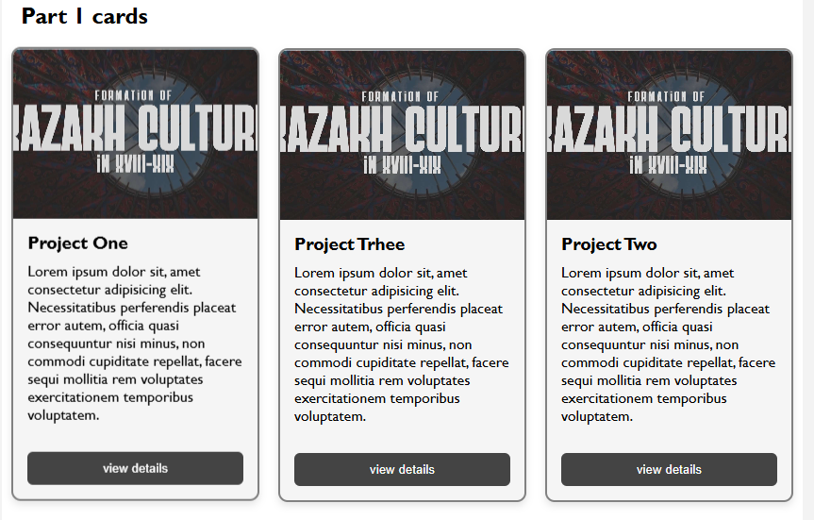

**Part 2. Grid System**

**Task 2. Page Layout with Grid Areas**

1. Set up a layout with a header, sidebar, main content, and footer.
2. Turn the parent container into a grid container.
3. Define grid rows and columns.
4. Assign grid areas so that:
   * The header spans across the top,
   * The sidebar is placed on the left,
   * The main content is on the right,
   * The footer spans across the bottom.
5. Confirm that each section fits correctly into its grid area.
6. <h2>Part 2 Grid</h2>
7. <div class="ex-box">
8. <div class="ex-head">
9. <p>Header area</p>
10. </div>
11. <div class="ex-main">
12. <p>Main content area</p>
13. </div>
14. <div class="ex-sidebar">
15. <p>Sidebar area</p>
16. </div>
17. <div class="ex-footer">
18. <p>footer area</p>
19. </div>
20. </div>

/* ----------------------grid---------------- */

1. .ex-box {
2. display: grid;
3. grid-template-areas:
4. "header header"
5. "sidebar main"
6. "footer footer";
7. grid-template-columns: 1fr 2fr;
8. grid-template-rows: 60px 1fr 60px;
9. gap: 10px;
10. height: 400px;
11. margin: 25px;
12. padding: 10px;
13. border: 2px dashed grey;
14. border-radius: 10px;
15. }
16. .ex-head {
17. grid-area: header;
18. background-color: rgba(89, 245, 245, 0.5);
19. border-radius: 7px;
20. }
21. .ex-main {
22. grid-area: main;
23. background-color: rgba(117, 255, 117, 0.5);
24. border-radius: 7px;
25. }
26. .ex-sidebar {
27. grid-area: sidebar;
28. background-color: rgba(252, 252, 86, 0.5);
29. border-radius: 7px;
30. }
31. .ex-footer {
32. grid-area: footer;
33. background-color: rgba(89, 245, 245, 0.5);
34. border-radius: 7px;
35. }

Изображение выглядит как текст, снимок экрана, Прямоугольник, Шрифт

Содержимое, созданное искусственным интеллектом, может быть неверным.

**Task 3. Image Gallery**

1. Collect at least nine images and place them inside a gallery container.
2. Set the gallery container as a grid container.
3. Define multiple equal-width columns and rows.
4. Add consistent spacing (gaps) between images.
5. Add a hover effect — for example, display a caption overlay when the user hovers over an image.
6. <h2>Part 2 images</h2>
7. <div class="img-box">
8. <div class="imag-bord">
9. <img src="1.jpg" alt="">
10. <p>image 1</p>
11. </div>
12. <div class="imag-bord">
13. <img src="1.jpg" alt="">
14. <p>image 2</p>
15. </div>
16. <div class="imag-bord">
17. <img src="1.jpg" alt="">
18. <p>image 3</p>
19. </div>
20. <div class="imag-bord">
21. <img src="1.jpg" alt="">
22. <p>image 4</p>
23. </div>
24. <div class="imag-bord">
25. <img src="1.jpg" alt="">
26. <p>image 5</p>
27. </div>
28. <div class="imag-bord">
29. <img src="1.jpg" alt="">
30. <p>image 6</p>
31. </div>
32. <div class="imag-bord">
33. <img src="1.jpg" alt="">
34. <p>image 7</p>
35. </div>
36. <div class="imag-bord">
37. <img src="1.jpg" alt="">
38. <p>image 8</p>
39. </div>
40. <div class="imag-bord">
41. <img src="1.jpg" alt="">
42. <p>image 9</p>
43. </div>
44. </div>

/* --------------img-box--------------------- */

1. .img-box {
2. display: flex;
3. flex-wrap: wrap;
4. gap: 20px;
5. margin: 0px 20px;
6. justify-content: space-evenly;
7. }
8. .imag-bord {
9. position: relative;
10. flex: 1 1 calc(33.333% - 20px);
11. display: flex;
12. justify-content: center;
13. align-items: center;
14. background: whitesmoke;
15. border: 2px solid rgb(179, 179, 179);
16. border-radius: 10px;
17. overflow: hidden;
18. box-shadow: 0 4px 8px rgba(0,0,0,0.1);
19. transition: transform 0.3s, box-shadow 0.3s;
20. }
21. .imag-bord p{
22. position: absolute;
23. display: flex;
24. bottom: 0;
25. background: rgba(0,0,0,0.6);
26. color: #fff;
27. padding: 10px 10px;
28. width: 100%;
29. margin: 0;
30. border-radius: 5px;
31. font-size: 14px;
32. justify-content: center;
33. opacity: 0;
34. }
35. .imag-bord:hover p {
36. opacity: 1;
37. }
38. .imag-bord:hover {
39. transform: scale(1.03);
40. box-shadow: 0 8px 16px rgba(0,0,0,0.15);
41. }
42. .imag-bord img {
43. width: 100%;
44. height: auto;
45. object-fit: cover;
46. }
47. @media (max-width: 900px) {
48. .imag-bord {
49. flex: 1 1 calc(50% - 20px);
50. }
51. }
52. @media (max-width: 600px) {
53. .imag-bord {
54. flex: 1 1 100%;
55. }
56. }

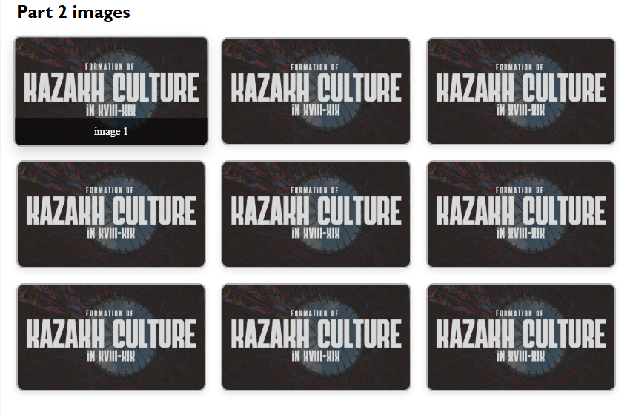

**Part 3. Combining Flexbox & Grid**

**Task 4. Portfolio Page**

1. Create a page structure with: header, main section, sidebar, and footer.
2. Use **Flexbox** in the header for the navigation bar.
3. Use **CSS Grid** for the main section:
   * Projects area on the left,
   * Info or sidebar on the right.
4. Inside each project card, use Flexbox to arrange content (title, description, button).
5. Ensure the footer spans across the bottom of the page.
6. Review the page for consistency in spacing and alignment.
7. <section class="part3-section">
8. <header class="part3-header">
9. <div class="part3-nav">
10. <a href="#">Logo</a>
11. <nav>
12. <ul>
13. <li><a href="#">Home</a></li>
14. <li><a href="#">Projects</a></li>
15. <li><a href="#">Contact</a></li>
16. </ul>
17. </nav>
18. </div>
19. </header>
20. <div class="part3-layout">
21. <div class="part3-projects">
22. <div class="part3-card">
23. <div class="part3-card-img"><img src="1.jpg" alt="project"></div>
24. <div class="part3-card-text">
25. <h3>Project A</h3>
26. <p>Lorem ipsum dolor sit amet consectetur adipiscing elit.</p>
27. </div>
28. <div class="part3-card-btn">
29. <button>View Details</button>
30. </div>
31. </div>
32. <div class="part3-card">
33. <div class="part3-card-img"><img src="1.jpg" alt="project"></div>
34. <div class="part3-card-text">
35. <h3>Project B</h3>
36. <p>Lorem ipsum, dolor sit amet consectetur adipisicing elit.</p>
37. </div>
38. <div class="part3-card-btn">
39. <button>View Details</button>
40. </div>
41. </div>
42. </div>
43. <!-- SIDEBAR -->
44. <aside class="part3-sidebar">
45. <h3>About Me</h3>
46. <p>Short description or sidebar info goes here.</p>
47. <ul>
48. <li>Skill 1</li>
49. <li>Skill 2</li>
50. <li>Skill 3</li>
51. </ul>
52. </aside>
53. </div>
54. <footer class="part3-footer">
55. <p>© 2025 My Portfolio</p>
56. </footer>
57. </section>
58. /* ---------- Part 3  ---------- */
59. .part3-section {
60. margin: 40px 0;
61. border: 2px dashed #aaa;
62. padding: 20px;
63. }
64. .part3-header {
65. background: #333;
66. color: white;
67. padding: 15px;
68. }
69. .part3-nav {
70. display: flex;
71. justify-content: space-between;
72. align-items: center;
73. }
74. .part3-nav ul {
75. list-style: none;
76. display: flex;
77. gap: 15px;
78. margin: 0;
79. padding: 0;
80. }
81. .part3-nav a {
82. color: white;
83. text-decoration: none;
84. }
85. .part3-layout {
86. display: grid;
87. grid-template-columns: 2fr 1fr;
88. gap: 20px;
89. margin: 20px 0;
90. }
91. .part3-projects {
92. display: flex;
93. flex-direction: column;
94. gap: 20px;
95. }
96. /* --------------PART CARD--------- */
97. .part3-card {
98. display: flex;
99. flex-direction: column;
100. border: 1px solid #ccc;
101. padding: 15px;
102. border-radius: 8px;
103. background: #fafafa;
104. }
105. .part3-card-img img {
106. width: 100%;
107. border-radius: 6px;
108. }
109. .part3-card-text {
110. margin: 10px 0;
111. }
112. .part3-card-btn {
113. margin-top: auto;
114. }
115. .part3-card-btn button {
116. padding: 8px 15px;
117. border: none;
118. background: #333;
119. color: white;
120. border-radius: 5px;
121. cursor: pointer;
122. }
123. .part3-card-btn button:hover {
124. background: #555;
125. }
126. /* ----------------PART Sidebar----------- */
127. .part3-sidebar {
128. background: #f0f0f0;
129. padding: 15px;
130. border-radius: 8px;
131. }
132. /* ------------PART Footer--------- */
133. .part3-footer {
134. background: #333;
135. color: white;
136. text-align: center;
137. padding: 15px;
138. }

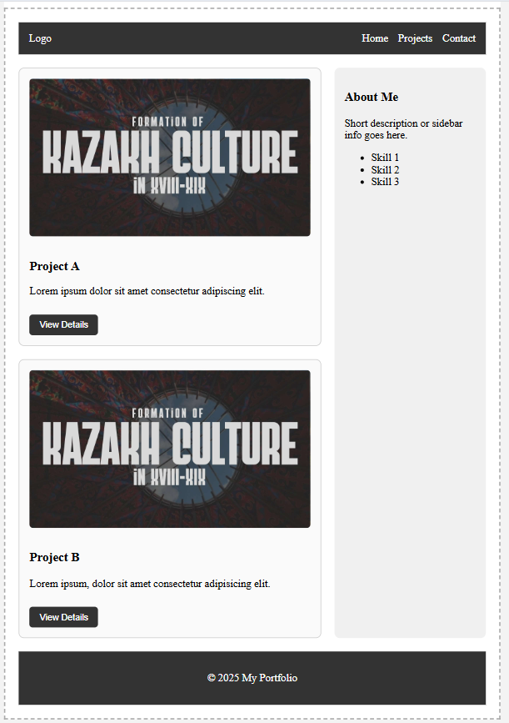

**Conclusion**

In this assignment, I learned how to use **Flexbox** and **CSS Grid** to create modern, responsive layouts.

* In **Part 1**, I built a navigation bar and card row using Flexbox, practicing horizontal and vertical alignment, spacing, and hover effects.
* In **Part 2**, I created a page layout and an image gallery with Grid, where I applied grid areas, rows, and columns to organize content effectively.
* In **Part 3**, I combined both Flexbox and Grid to structure a portfolio page with a header, main content, sidebar, and footer, while arranging project cards neatly with Flexbox inside the grid.

Through these tasks, I strengthened my understanding of how to combine Flexbox and Grid, improved consistency in spacing and alignment, and gained practical experience in building structured, responsive, and visually balanced web pages.